### 

### 

### **Comprehensive Loan Performance and Risk Mitigation Report**

Author:Joseph Kibira

Date:21/03/2025

### 

### 

### 

### 

### 

### 

### 

### 

### 

### 

### 

### 

### 

### 

### 

### 

### **Table of Contents**

### 

Comprehensive Loan Performance and Risk Mitigation Report 1

Table of Contents 2

**1. Overview 3**

**2. Loan Disbursement vs. Repayment Trends 3**

Key Insights: 3

Graph 1: Loan Disbursements vs. Repayments Over Time 3

**3. Forecasted Loan Disbursements and Repayments 3**

Key Forecasting Insights: 3

Graph 2: Forecasted Loan Disbursements and Repayments 4

**4. Recommendations 4**

4.1 Introduce Credit Scoring Algorithms 4

Graph 3: Forecasted Loan Disbursements and Repayments Summary 4

4.2 Dynamic Loan Terms Based on Risk Profile 5

4.3 Proactive Loan Restructuring for At-Risk Borrowers 5

4.4 Incentivize Early Repayment 5

**5. Conclusion 6**

Data Sources and Methods 7

Key Sections Explained 7

1.1 Loan Disbursement vs. Repayment Trends 7

1.2 Forecasted Loan Disbursements and Repayments 7

Recommendations and Their Purpose 7

2.1 Credit Scoring System 8

2.2 Adjusting Loan Terms Based on Risk 8

2.3 Helping Borrowers in Financial Trouble 8

2.4 Encouraging Early Repayments 8

### 

### 

## **1. Overview**

This report provides an in-depth analysis of loan disbursements and repayments, identifies key trends, and recommends strategies to enhance financial sustainability. The findings are supported by data-driven insights and visualizations.

## **2. Loan Disbursement vs. Repayment Trends**

### **Key Insights:**

* Loan disbursements showed an upward trend until April 2024, followed by a decline.
* Repayments remained relatively stable but started exceeding disbursements from August 2024, signaling a shift in borrower behavior.
* A significant drop in disbursements in mid-2024 suggests a need for revised lending strategies.

### **Graph 1: Loan Disbursements vs. Repayments Over Time**

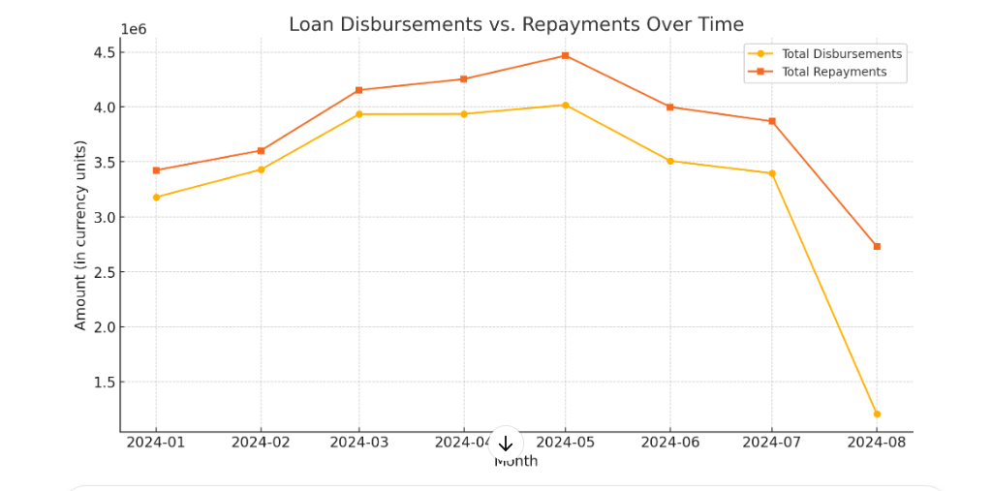

## **3. Forecasted Loan Disbursements and Repayments**

### **Key Forecasting Insights:**

* Using Holt-Winters exponential smoothing, projections indicate a continued decline in disbursements unless corrective measures are taken.
* Repayments are expected to remain stable but may slightly decrease in response to reduced loan issuance.

### **Graph 2: Forecasted Loan Disbursements and Repayments**

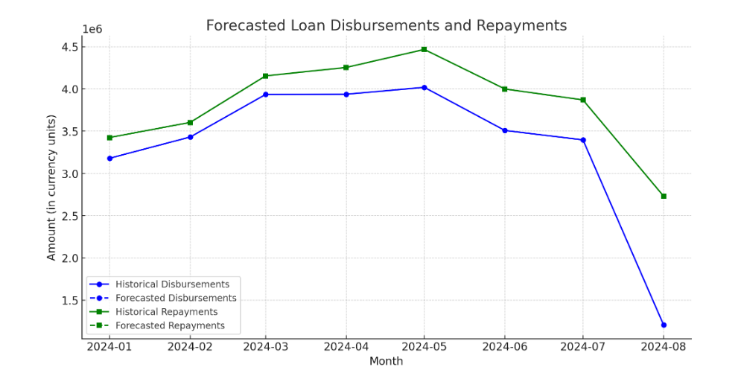

## **4. Recommendations**

### **4.1 Introduce Credit Scoring Algorithms**

* A credit scoring model using machine learning should be implemented to enhance risk assessment accuracy.
* Additional data sources should be integrated, including:
  + **Transaction history** (e.g., mobile money transactions, utility bill payments).
  + **Employment stability** (e.g., job duration, income consistency).
  + **Demographic factors** (e.g., age, education level).
* Benefits:
  + Improved loan structuring to match repayment capabilities.
  + Higher profitability by reducing default risks.

### **Graph 3: Forecasted Loan Disbursements and Repayments Summary**

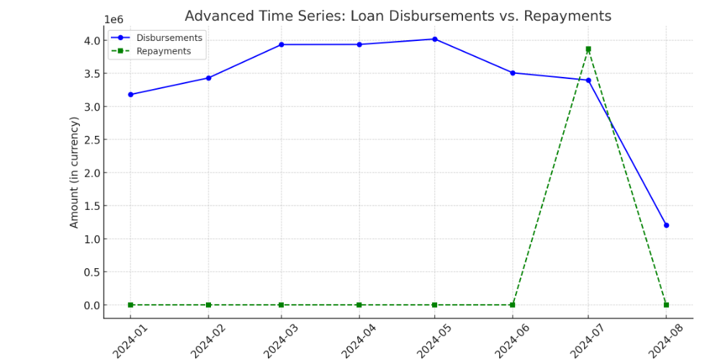

### **4.2 Dynamic Loan Terms Based on Risk Profile**

* High-risk borrowers should be assigned tailored loan conditions:
  + Shorter loan tenures to reduce default risks.
  + Loan amounts proportional to repayment capabilities.
  + Higher interest rates to offset risks.
* Low-risk borrowers should receive:
  + Larger loans with longer repayment periods.
  + Lower interest rates to encourage responsible borrowing.
* This segmentation ensures sustainable lending practices and optimized portfolio performance.

### **4.3 Proactive Loan Restructuring for At-Risk Borrowers**

* Identify struggling borrowers using credit scoring models.
* Implement flexible repayment options:
  + Extended loan tenures to lower monthly payments.
  + Temporary interest-only repayment arrangements.
  + Reduced interest rates for borrowers facing unexpected financial hardships.
* These measures will mitigate default risks and maintain financial stability.

### **4.4 Incentivize Early Repayment**

* Encourage borrowers to pay off loans early by offering incentives:
  + Lower interest rates for early payments.
  + Reduced loan fees for pre-scheduled repayments.
* This strategy enhances cash flow and improves loan recovery rates.

## **5. Conclusion**

By implementing these data-driven recommendations, the organization can optimize loan performance, reduce default risks, and ensure long-term financial growth. The integration of credit scoring, adaptive loan terms, restructuring strategies, and repayment incentives will drive sustainability and profitability.

**Appendix: Simple Explanation of the Comprehensive Loan Performance and Risk Mitigation Report**

### **Data Sources and Methods**

* **Loan Disbursement and Repayment Data:** Information from financial records showing past loan trends.
* **Forecasting Model:** Uses a statistical method (Holt-Winters model) to predict future loan disbursements and repayments.
  + **Holt-Winters Model:** A time series forecasting technique that considers past trends, seasonal variations, and patterns to make predictions.
  + **Trend Component:** Detects whether loans are increasing or decreasing over time.
  + **Seasonal Component:** Adjusts for recurring patterns (e.g., increased borrowing in certain months).
  + **Smoothing Factor:** Reduces fluctuations in data to make accurate forecasts.
* **Risk Assessment:** Uses a credit scoring system that looks at:
  + **Transaction History:** How often and how much borrowers spend.
  + **Employment Stability:** How long someone has had a job and their income level.
  + **Demographics:** Age, education, and location.

### **Key Sections Explained**

#### **1.1 Loan Disbursement vs. Repayment Trends**

* More loans were given out until April 2024, then lending slowed down.
* Repayments stayed stable but started being higher than new loans from August 2024.
* A sudden drop in loans in mid-2024 suggests changes are needed in lending policies.

**Graph 1: Loan Disbursements vs. Repayments Over Time**

* Shows how lending and repayments have changed over time.

#### **1.2 Forecasted Loan Disbursements and Repayments**

* If no action is taken, fewer loans will be given out in the future.
* Repayments will stay steady but may go down slightly due to fewer loans being issued.
* Forecasting considers historical trends to anticipate changes in loan activity.

**Graph 2: Forecasted Loan Disbursements and Repayments**

* Shows expected loan trends based on past data.

### **Recommendations and Their Purpose**

#### **2.1 Credit Scoring System**

* Use machine learning to better predict who is likely to repay their loans.
* Consider transaction history, job stability, and demographics to assess risk.
* Helps give loans to people who can repay while reducing losses.

#### **2.2 Adjusting Loan Terms Based on Risk**

* **For High-Risk Borrowers:**
  + Shorter loan periods to lower the risk of default.
  + Smaller loan amounts based on repayment ability.
  + Higher interest rates to balance the risk.
* **For Low-Risk Borrowers:**
  + Larger loans with longer repayment periods.
  + Lower interest rates to reward good financial behavior.
* Helps maintain financial stability by reducing unnecessary risks.

#### **2.3 Helping Borrowers in Financial Trouble**

* Use credit scoring to identify borrowers struggling to repay.
* Offer flexible repayment options such as:
  + Extending loan periods to lower monthly payments.
  + Temporary interest-only payments to ease financial pressure.
  + Adjusting interest rates for those facing financial hardship.
* Helps prevent defaults while keeping the loan system sustainable.

#### **2.4 Encouraging Early Repayments**

* Offer rewards for borrowers who repay loans early:
  + Lower interest rates.
  + Reduced loan fees for scheduled prepayments.
* Improves cash flow and ensures loans are recovered faster.